**CMPE-250 Laboratory Exercise Eleven**

**D/A Conversion, A/D Conversion, PWM, & Servos with Mixed Assembly Language and C**

By submitting this report, I attest that its contents are wholly my individual writing about this exercise and that they reflect the submitted code. I further acknowledge that permitted collaboration for this exercise consists only of discussions of concepts with course staff and fellow students; however, other than code provided by the instructor for this exercise, all code was developed by me.



Dean Trivisani

Performed November 14, 2017

Submitted November 27, 2017

Lab Section 01L2

Instructor: Melton

TA: Donald Mannise

Michael Baumgarten

Matthew Toro

Lecture Section 01

Professor: Melton

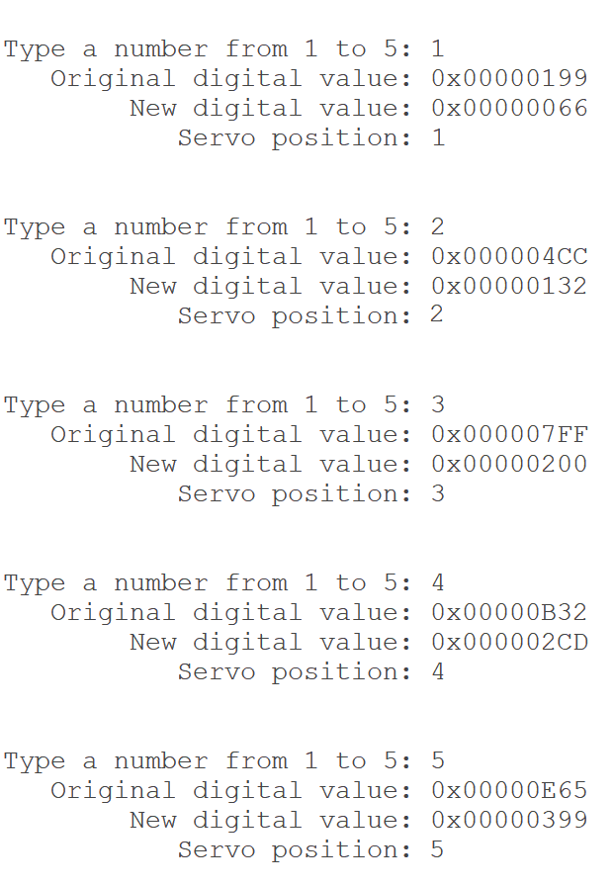

Figure 1: The test values produced in the command line entries show correct operation, as they compare exactly with those provided and expected through calculation

Device programming in C versus assembly language provides an interesting juxtaposition of coding styles. While assembly requires long and extremely deliberate instructions for everything to work, C requires far less actual coding in order to be implemented, as well as having a classic syntax that any programmer will be able to familiarize themselves with quickly.

